Nim : 32230107
Nama : Steven Setiawan
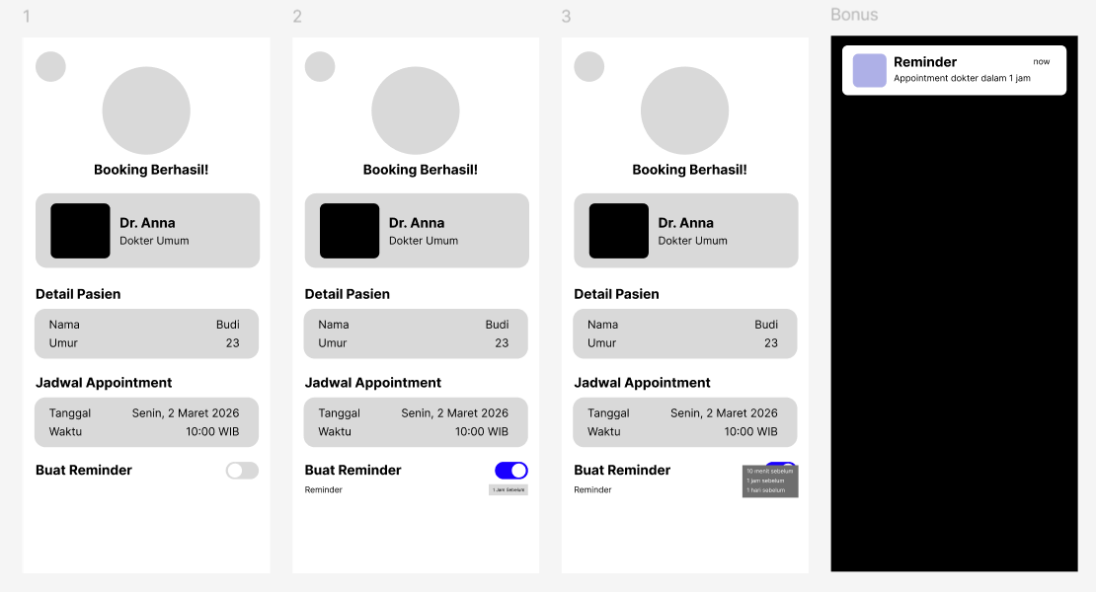
Link Figma:
https://www.figma.com/design/5e6059cCz2hLA6HAvSepqr/Untitled?node-id=0-1&t=uu8vjTVaLeWnToje-1

